Two channels pulse output
Summary
Generally, XC3 and XC5 series PLC’s support 2 (two) channels pulse outputs. In order to use pulse outputs, please choose PLC with transistor outputs. Via using different instructions, you can realize not only one-direction pulse outputs without speed-up/speed-down, one-direction pulse outputs with speed-up/speed-down, but also multi-segment, positive/negative direction outputs etc. The output frequency can reach 400KHz.
In this sample, we use single-segment, one direction pulse output, Y0 controls X axis step motor, Y1 controls Y axis step motor. Control the two axis to drive alternatively via flow.
Graph:
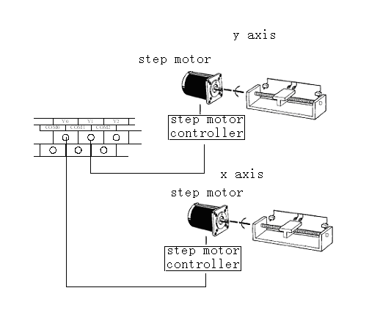

Flow Chart:

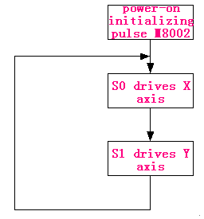
Program:

